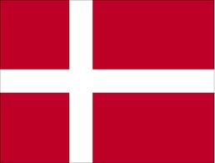

PROJECT DENMARK AT MEDVEDGRAD PRIMARY SCHOOL
On Friday 11 May 2012 a workshop presenting different aspects of Danish culture was held in English at Medvedgrad Primary School in Zagreb. Apart from students and teachers, it was attended by our dear guests, the Danish Ambassador Mr Bo Eric Webber, his wife Mrs Anni Suhr Webber and Mr Tomislav Gugo, the PD and Communication Manager of the Danish Embassy in Zagreb. It started at 12 am and lasted until 1 pm. The project was presented by the students of the 1, 3, 6, 7 and 8 grades with help of their teachers, who were very supportive while the project was being prepared.
This workshop had been planned for a long time and was finally carried out after a lot of hard work by keen students, teachers and the entire school staff. The topics of the workshop were arranged in the way that the students would present the work they had done and then ask questions which arose in the course of their research. The Ambassador would answer those questions and the next topic was then introduced by the moderator Mrs Dubravka Rojc.
The Ambassador's responds to our questions were really educational and extremely interesting. We could learn a lot not only by listening to what he said but also by paying attention to the way he said it. It was also excellent listening practice, since a lot of our colleagues have never listened to so much English at once in their lives!
The workshop was followed by homemade refreshments prepared by Mrs Jadranka Peroš. Students and teachers had an opportunity to ask the guests some additional questions and practise their language skills, engaging in less formal conversation. 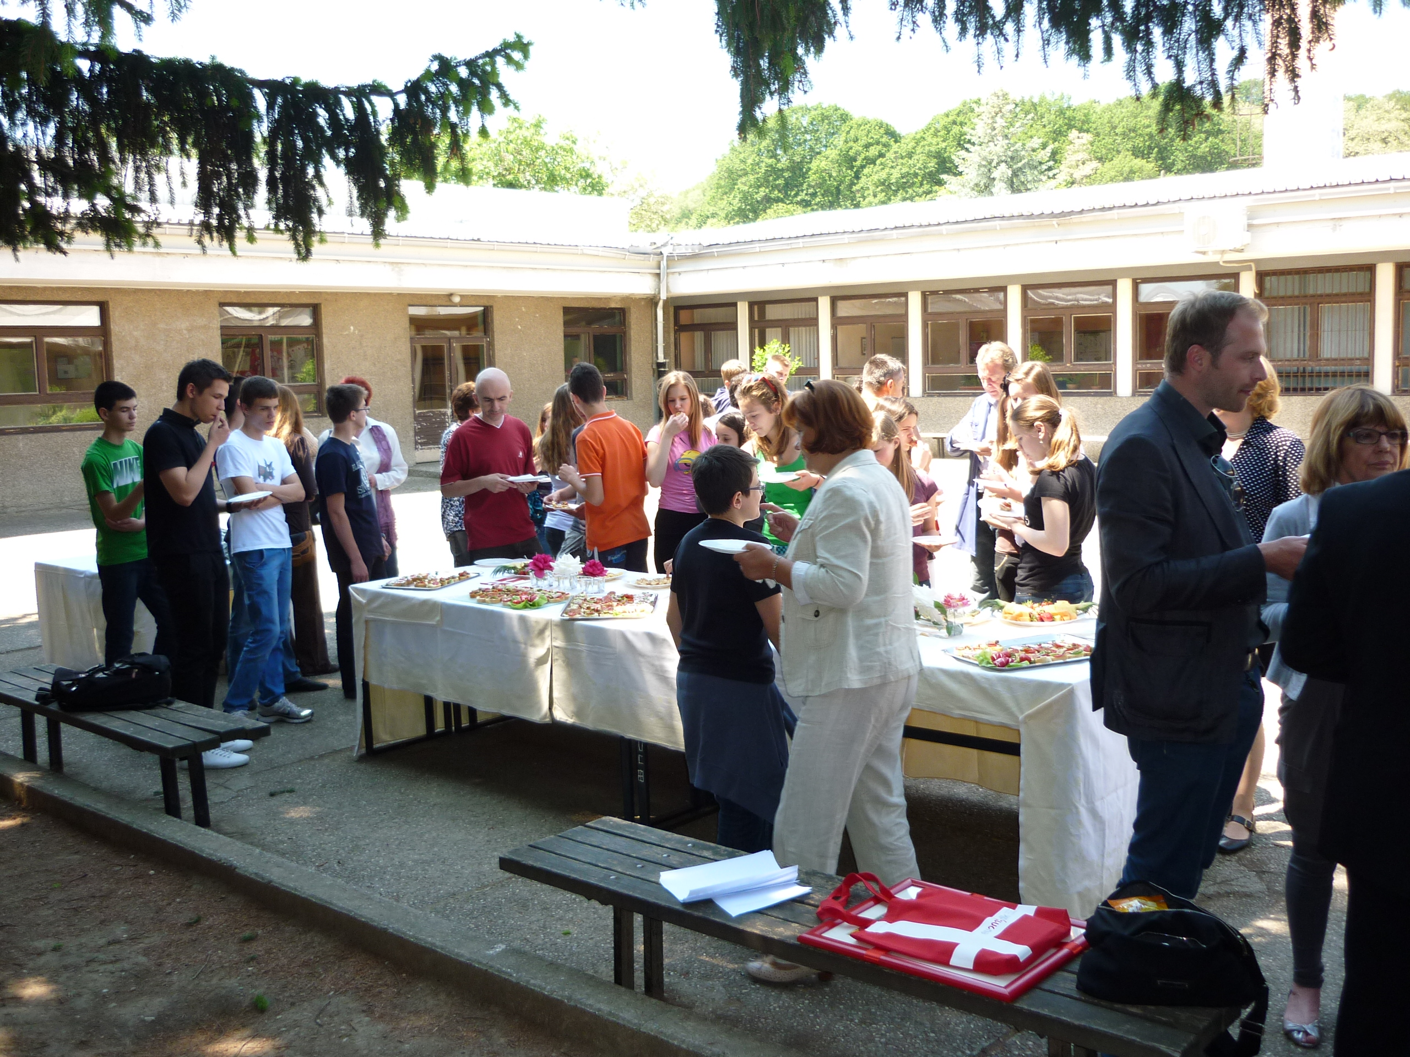 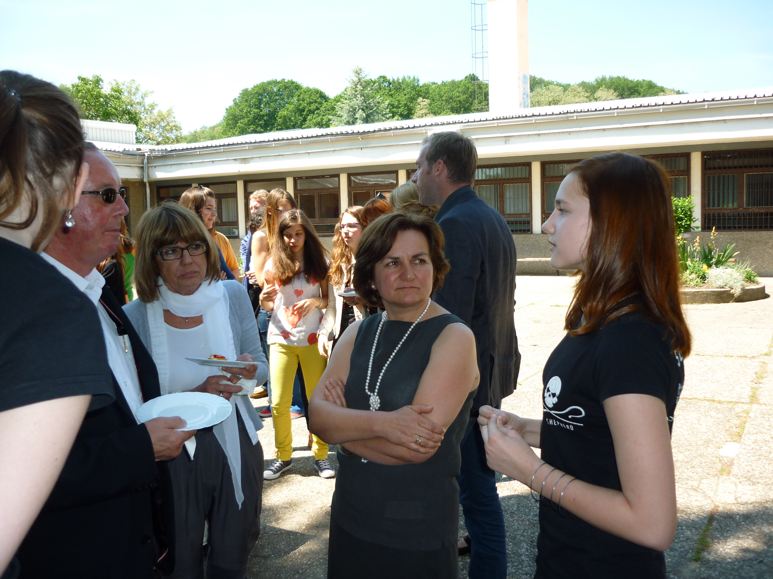 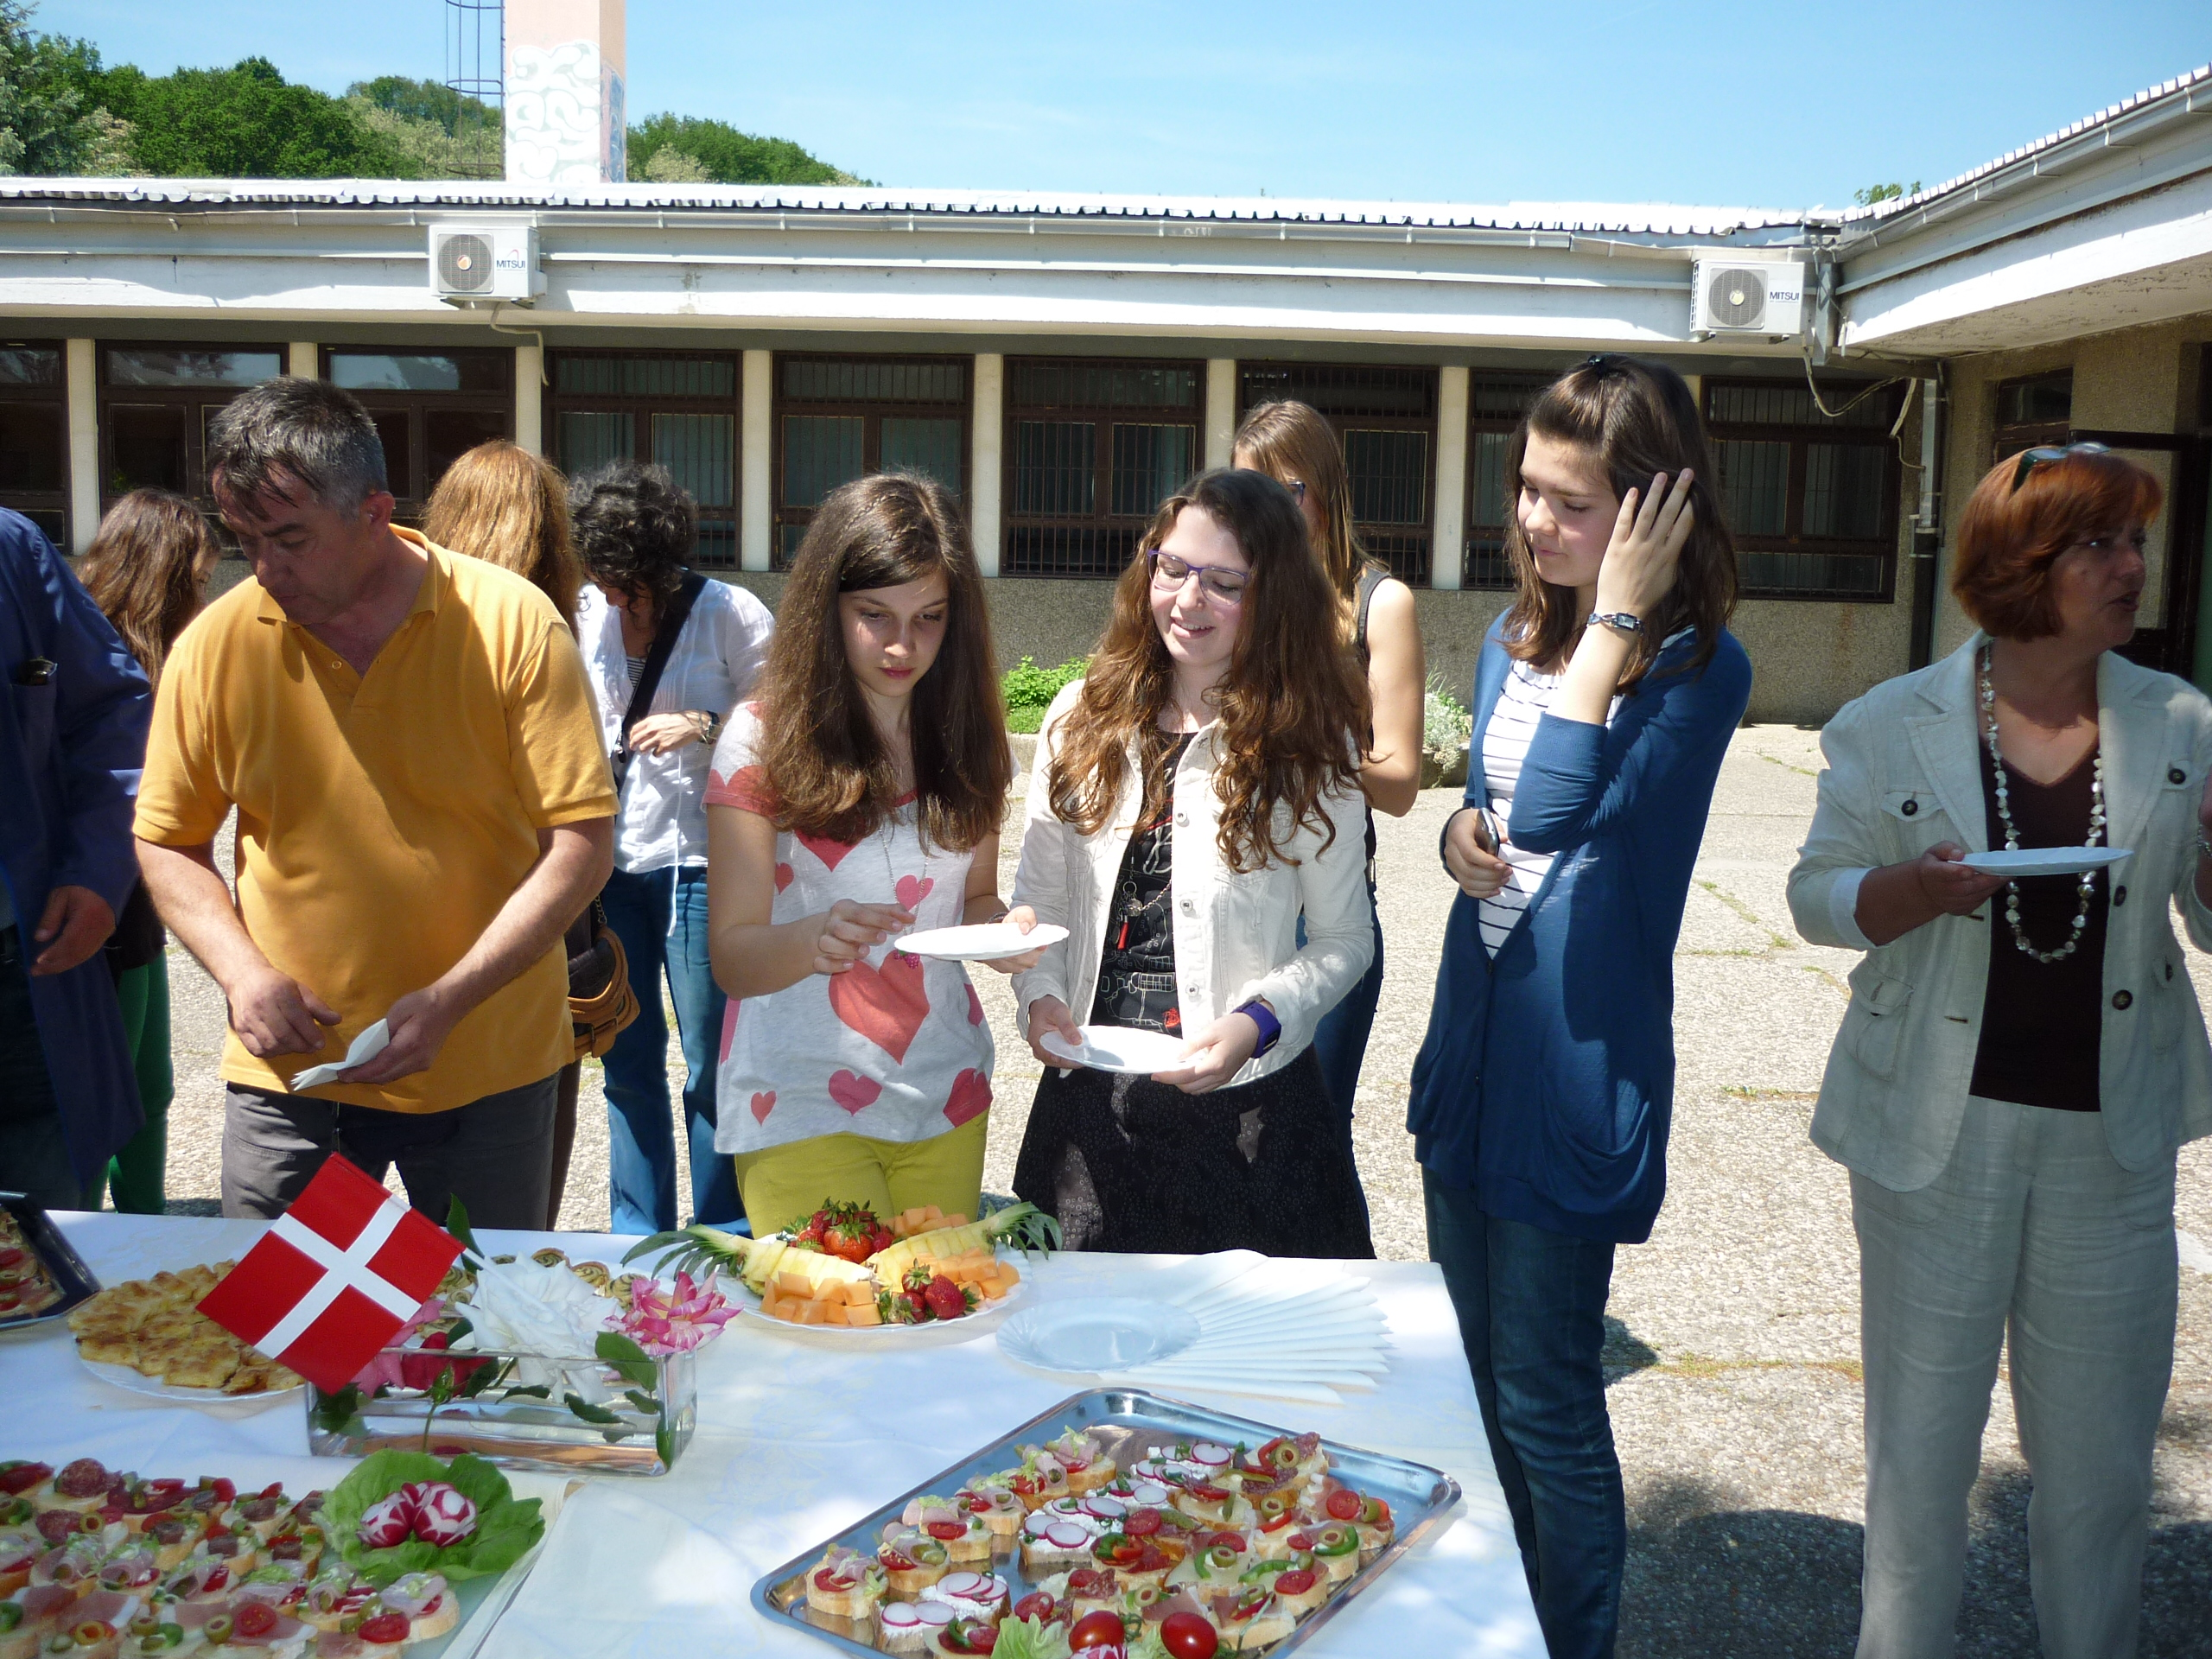 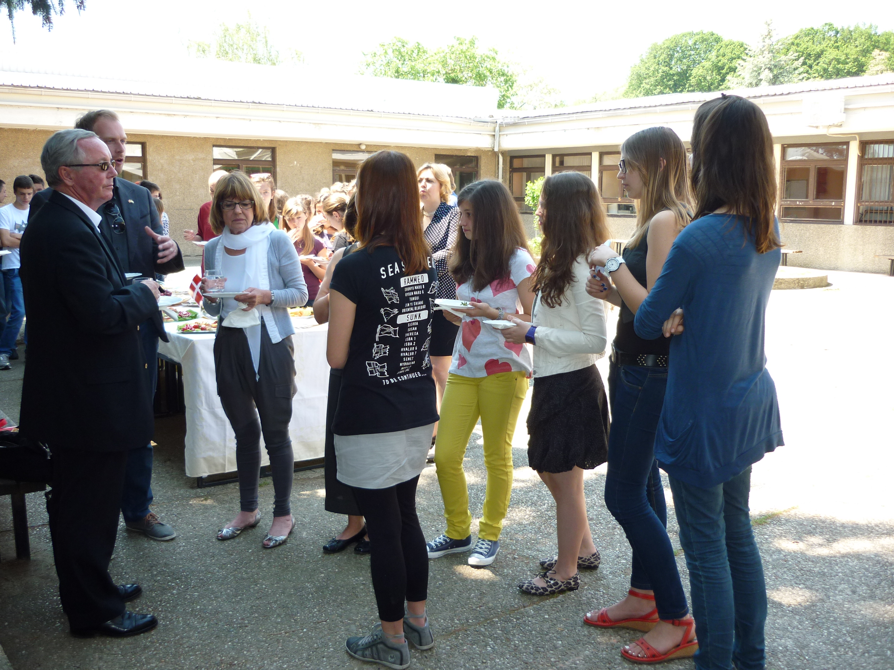
The project was carried out in the school hall in several stages, including two short plays (The Emperor's New Clothes and a short version of Shakespeare's Hamlet by the shadow theatre). Some philosophical questions raised by Ankica Pezo and Iva Balatinec followed each topic.
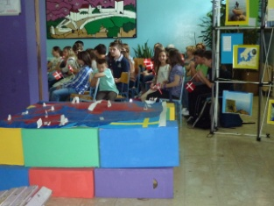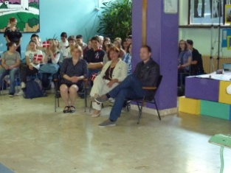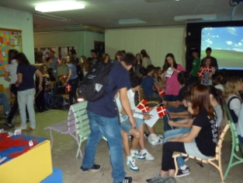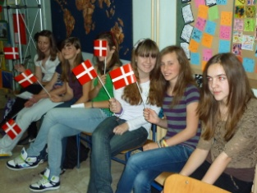
GEOGRAPHY
Climate, agriculture, population and traffic were presented by Josipa Milić, Kika Vidić, Magdalena Novosel and Marta Sobota (grade 7). Tamara Križetić and Matea Čulina (grade 8) made a geographical map of Denmark which was decorated with all the famous Danish landmarks and people.
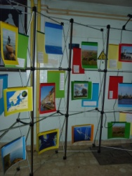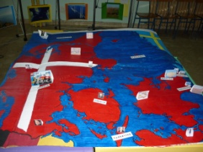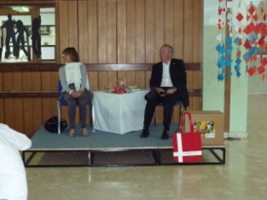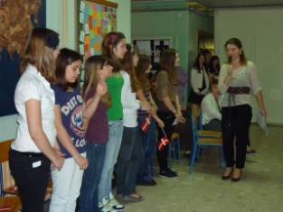
HISTORY
Denmark as the oldest kingdom in the world and the Vikings were presented by Kristian Pries, Dominik Vladić, Mislav Grubišić (grade 8) and Viktor Krklec (grade 6). The boys mentioned all the reasons why Denmark carries this title and told us the real story of the Vikings, which was unknown to most of us.
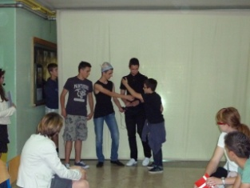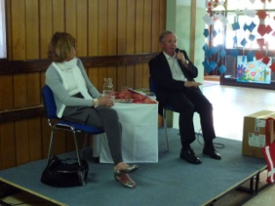
ART
Danish design was presented by Ivana Eranović and Valentina Mikuš (grade 8). The girls talked about the most important Danish designers and architects and also showed us their world-known masterpieces.
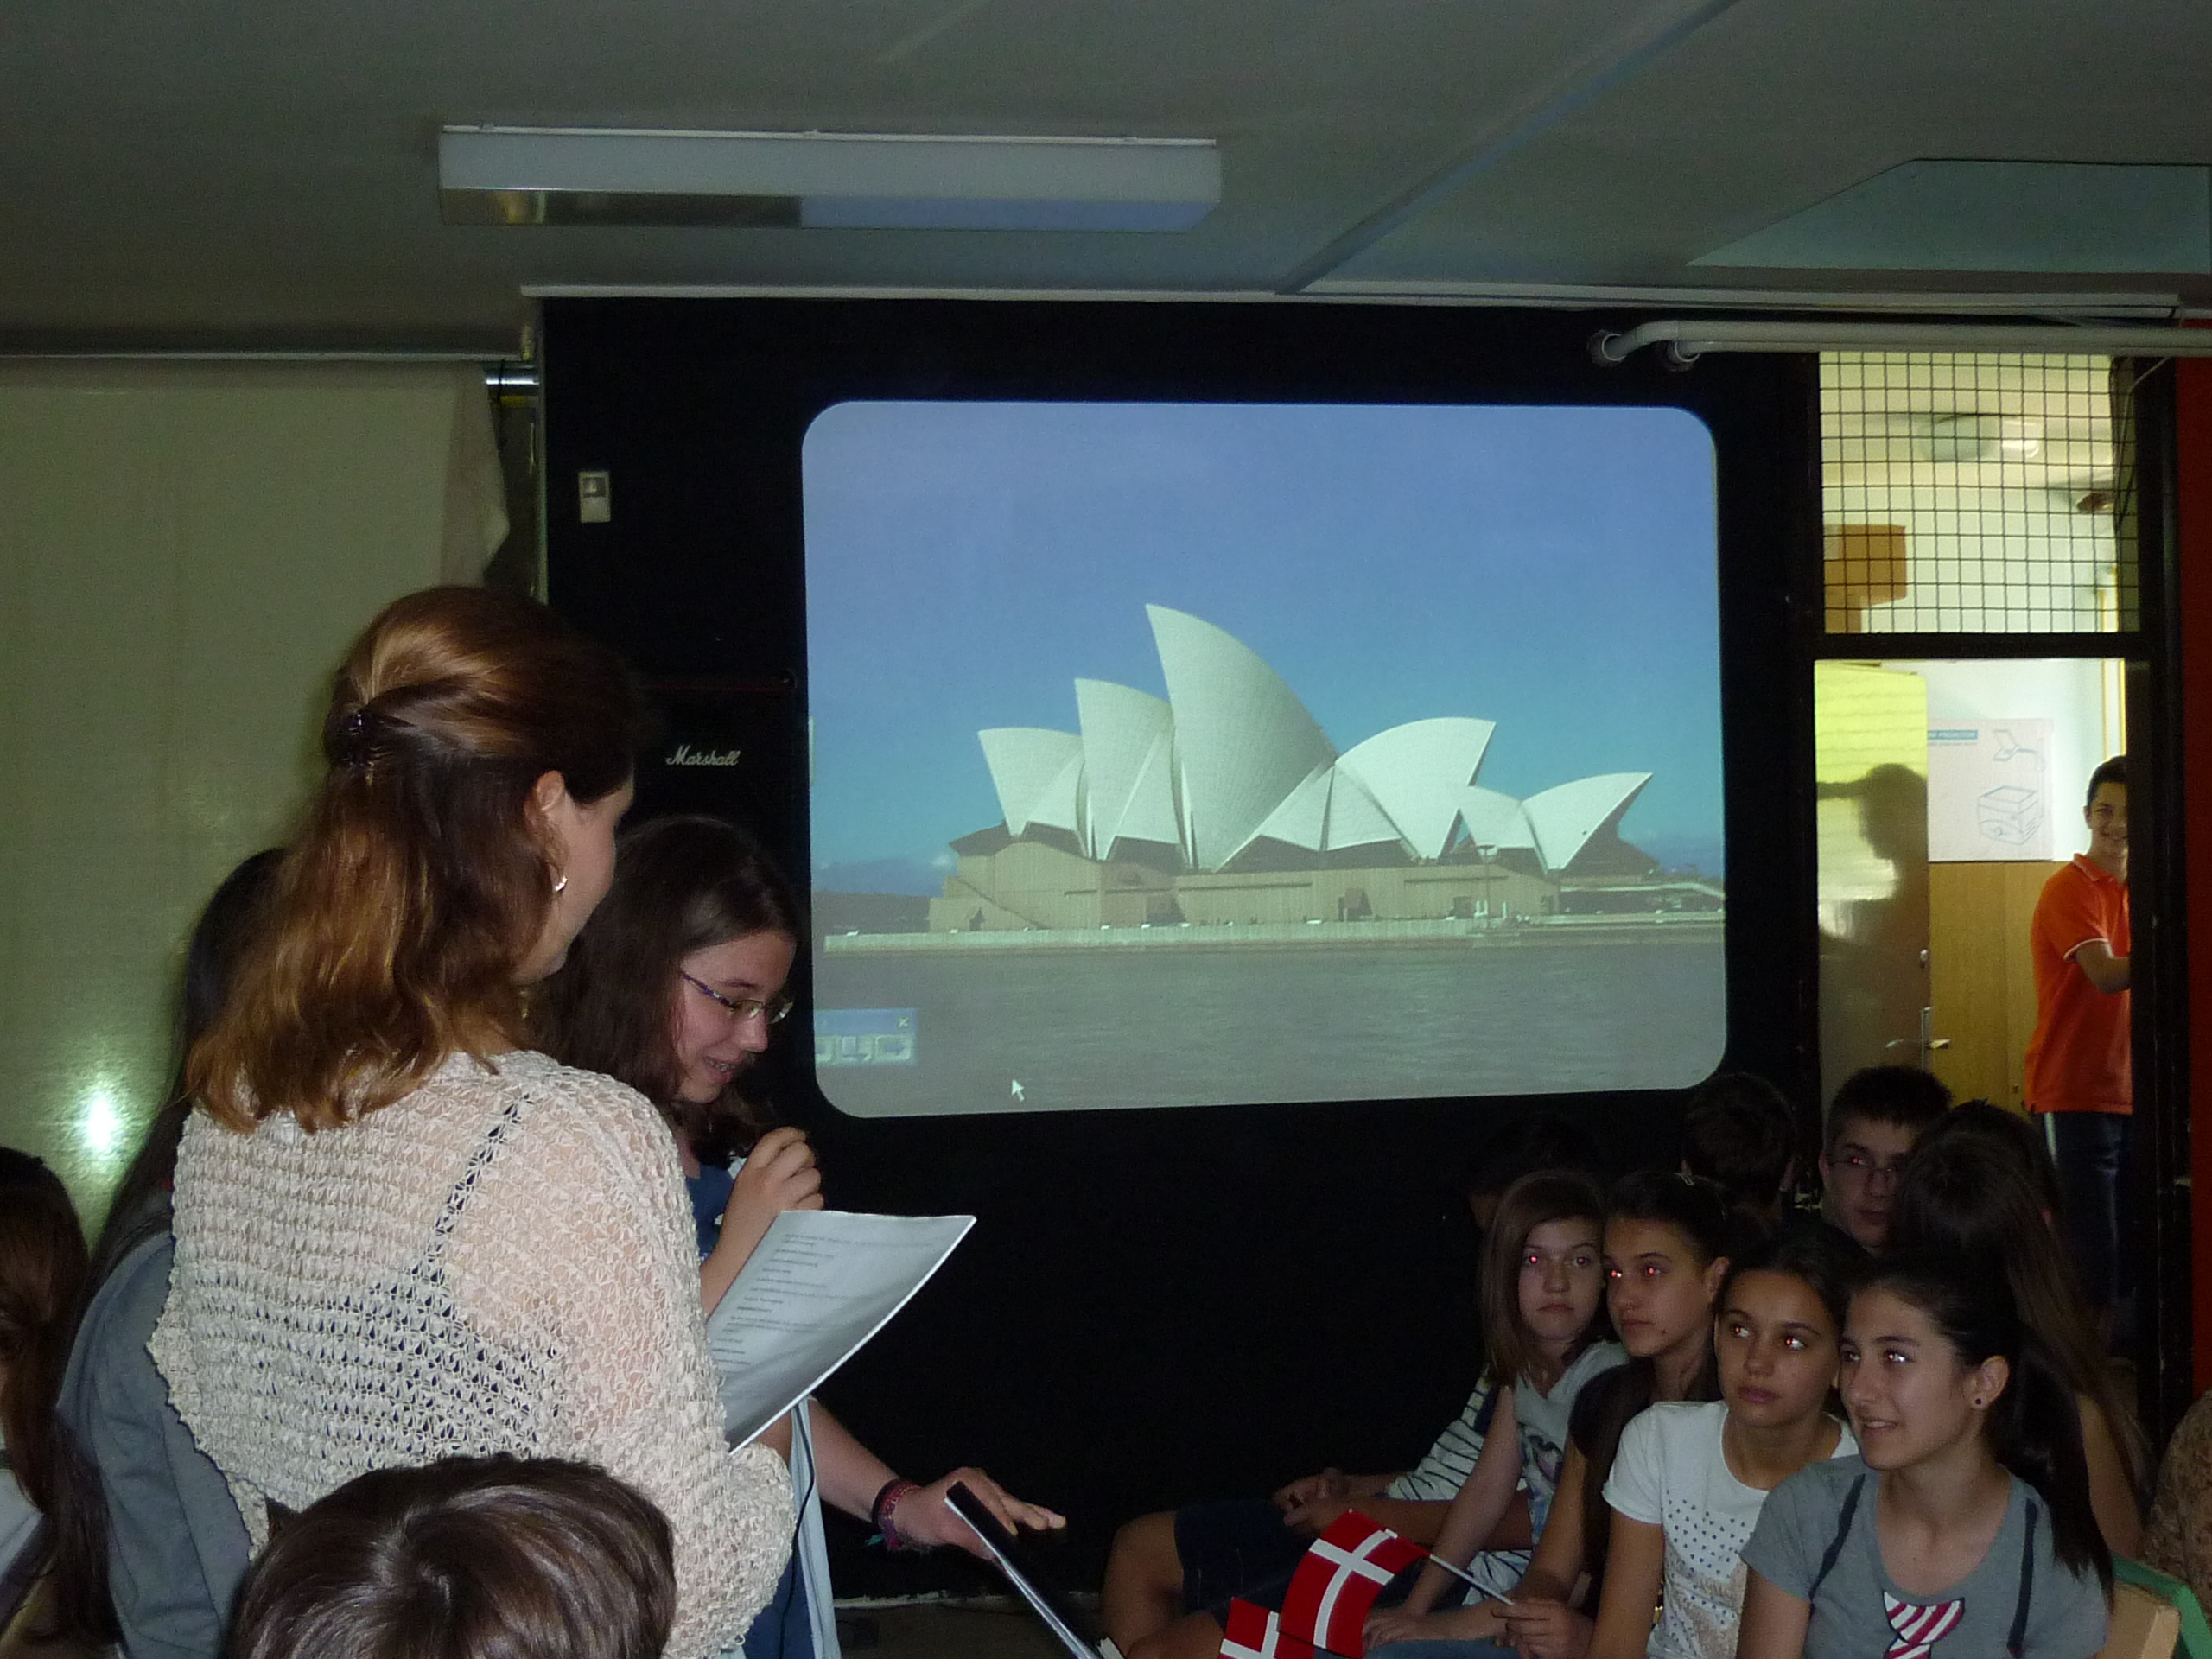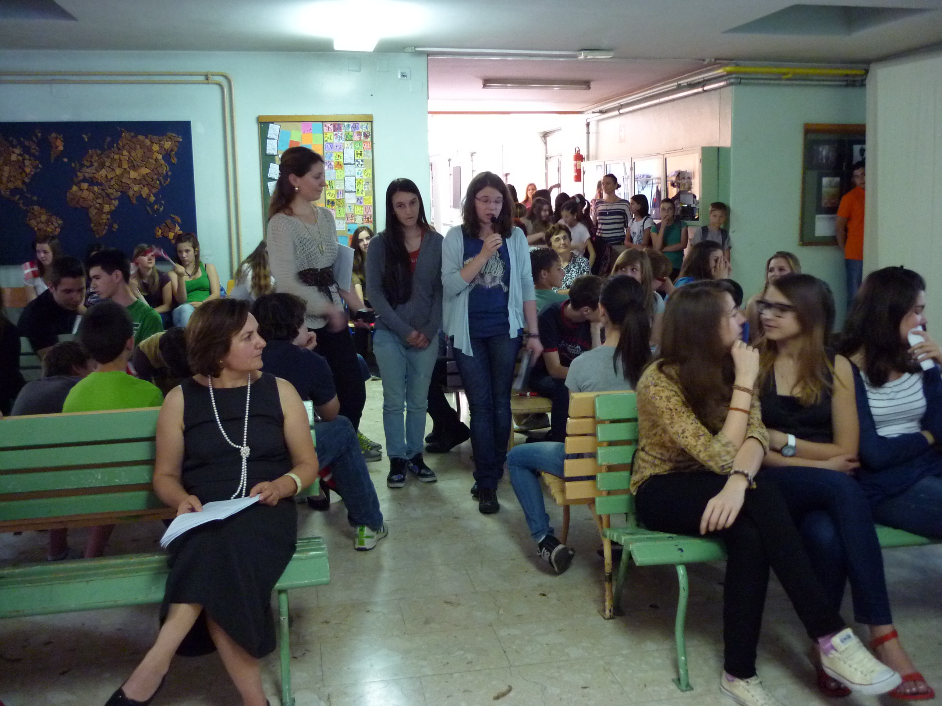
CROATIAN LANGUAGE
Hans Christian Andersen’s fairy tales were presented by Karla Krajač (grade 7). Karla talked about the importance of telling fairy tales to children and Andersen’s literary significance.
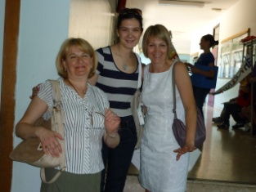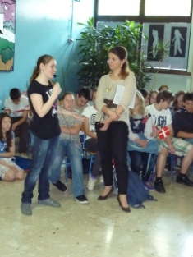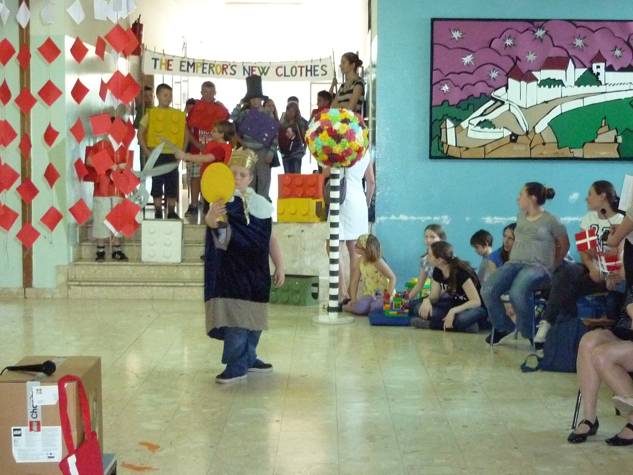
PHYSICS
This topic was introduced by presenting the work and life of the famous Danish Nobel prize winner Niels Bohr. Niels Bohr’s life was connected to the current Danish technology and science. His work was presented by Iva Slonjšak and Petar Mislović (grade 8).
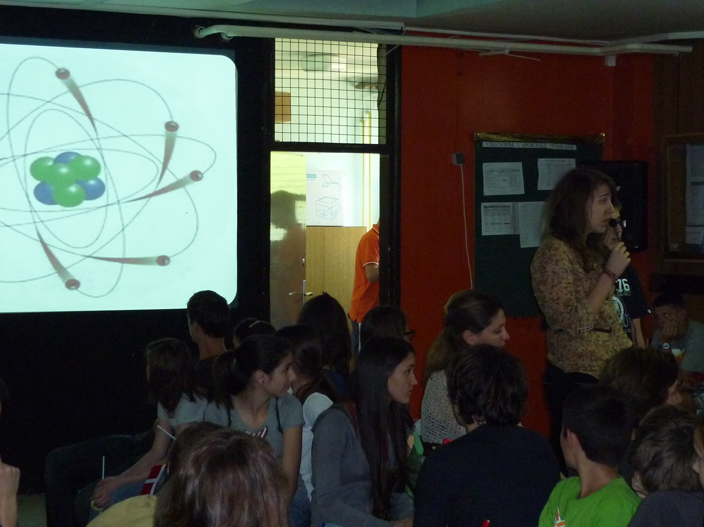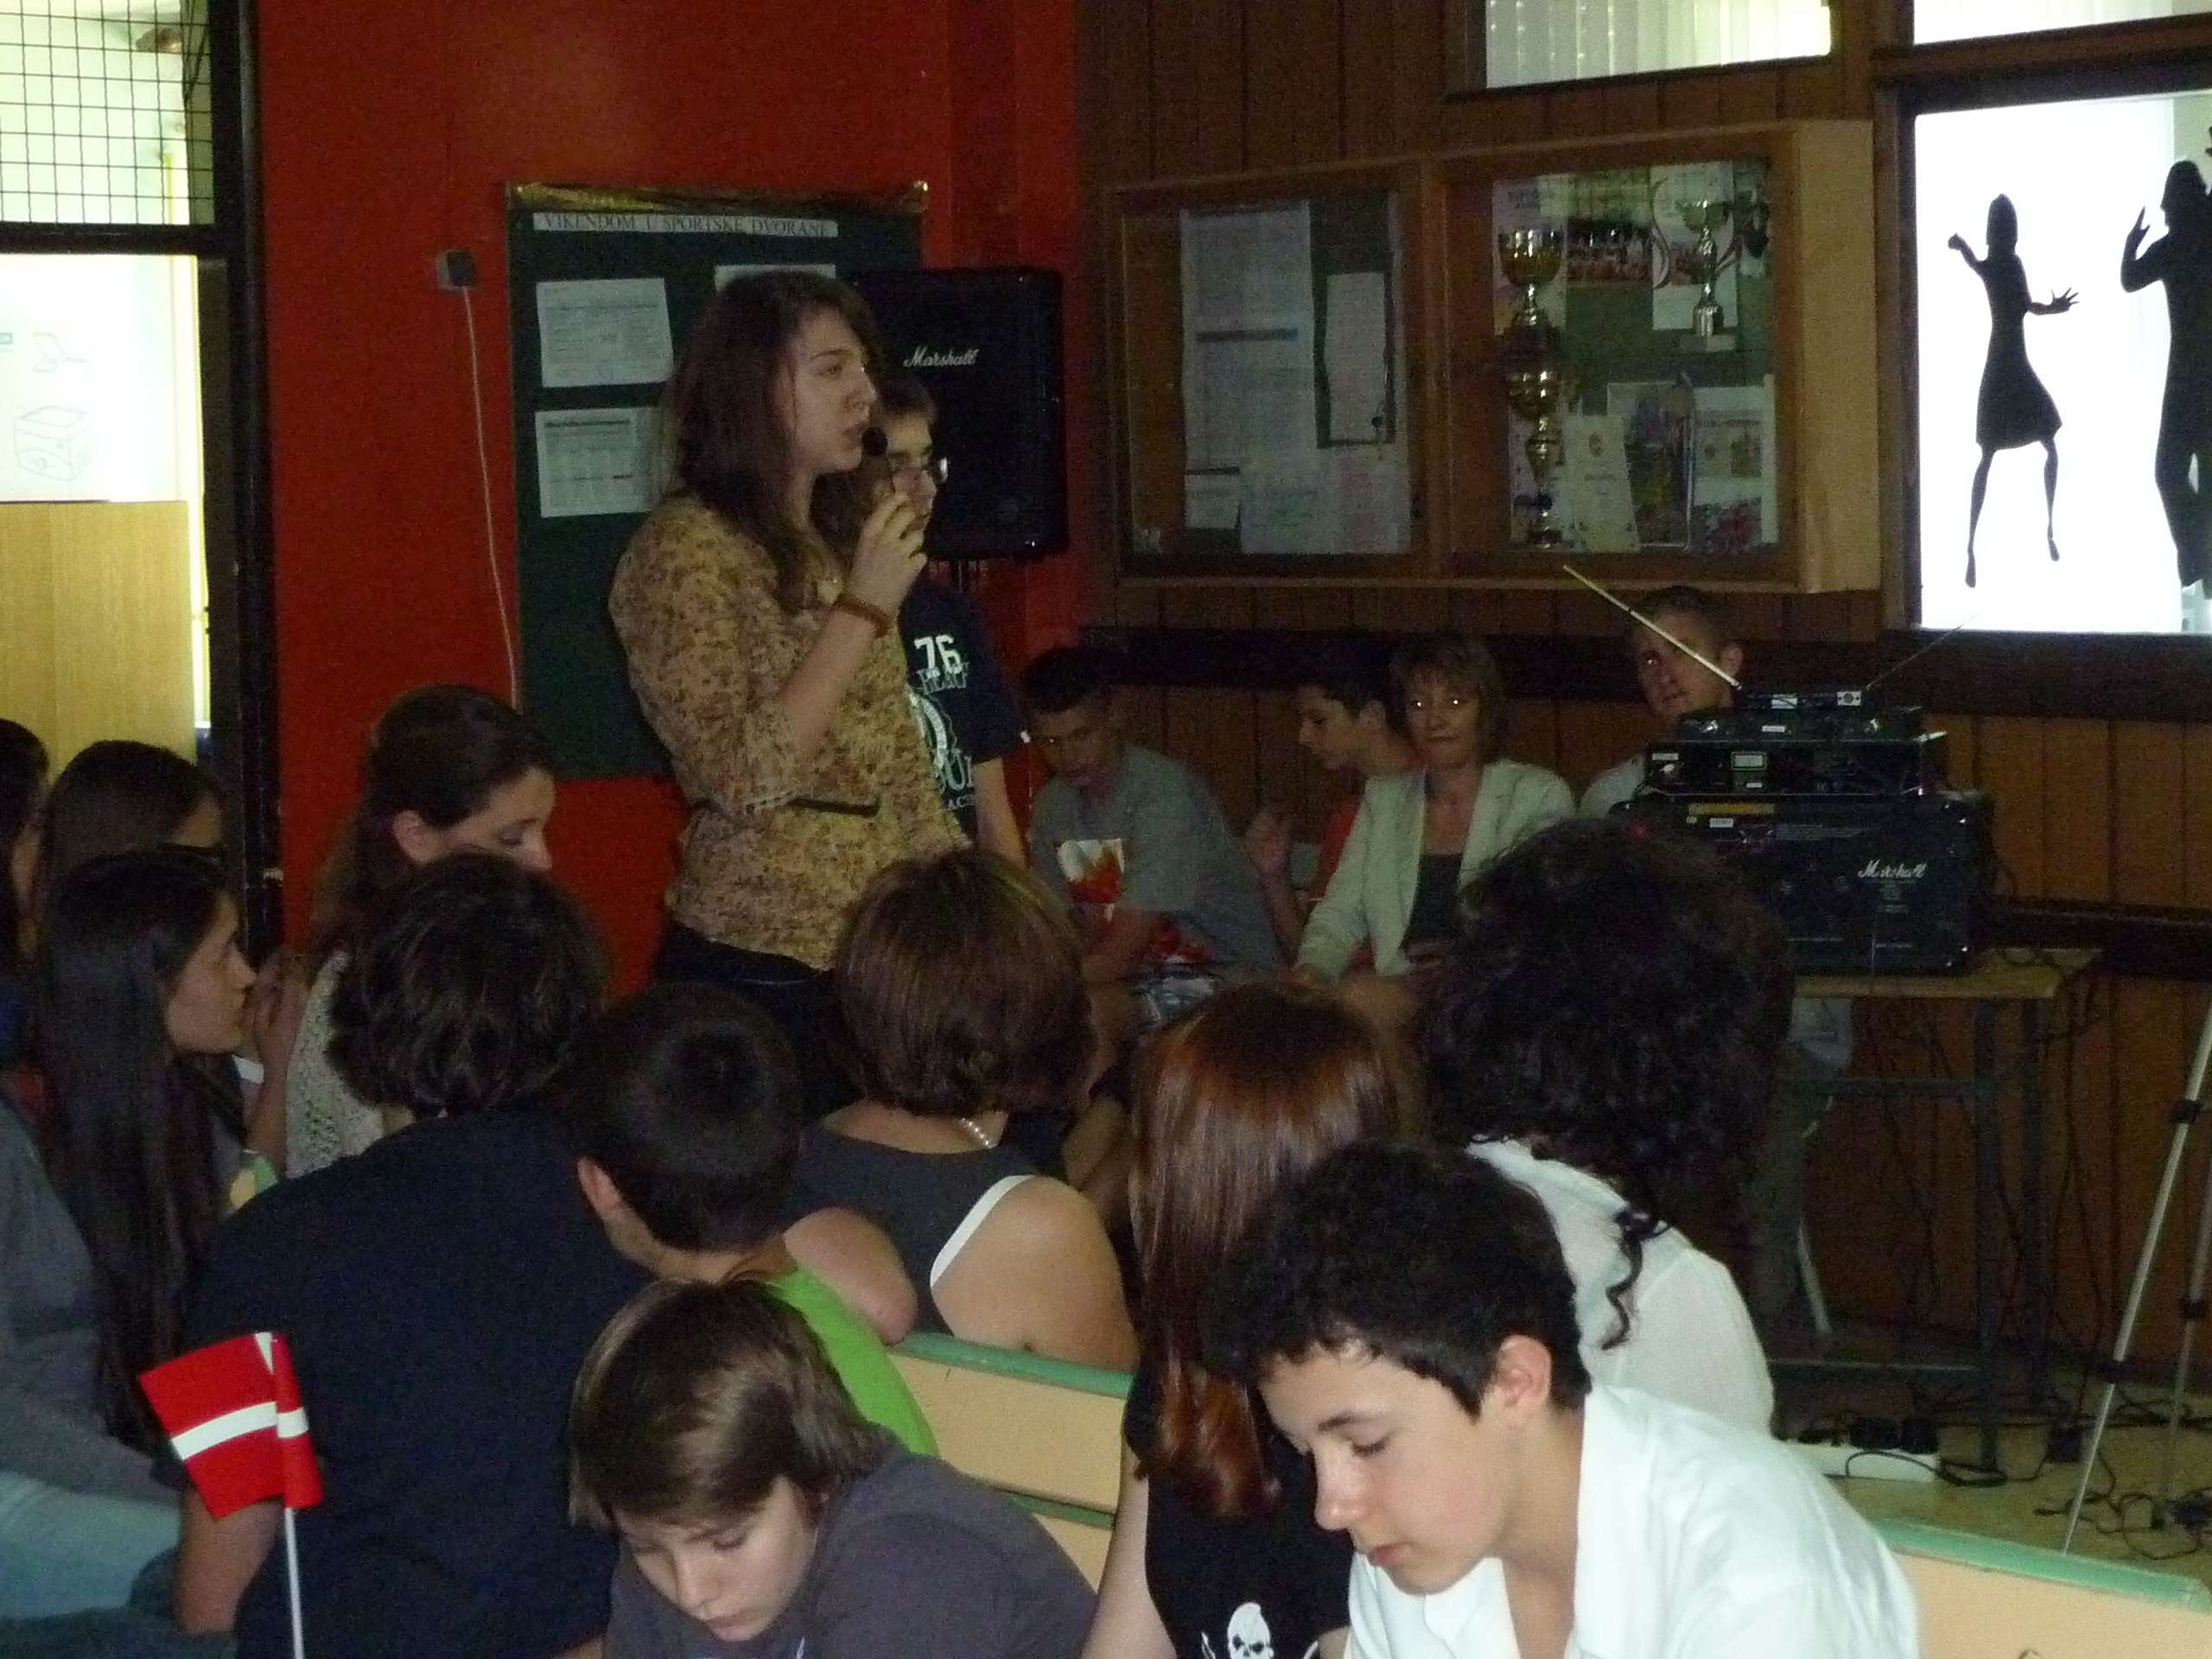
CITIZENSHIP
The famous Democritus’ atomic hypothesis helped us understand the brilliance of Lego blocks. The topic was presented by Ankica Pezo and Iva Balatinec (grade 8) with help of some 1 graders showing how to play with Legos.
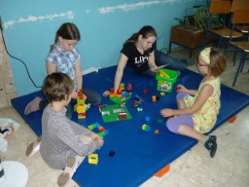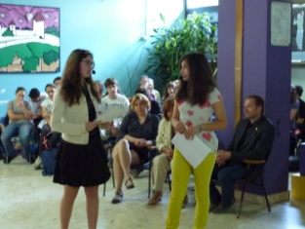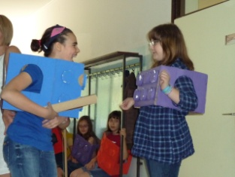
THEOLOGY & RELIGION
This topic arouse when we heard about the issue of Denmark wanting to become a Down syndrome free country. This topic was a little bit more serious than all the other ones. However, we think that our Ivan Čulo (grade 8) handled it very well.
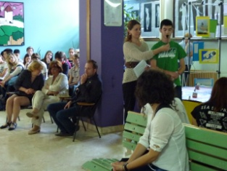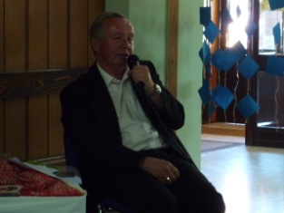
CITIZENSHIP
Tea Markovinović and Mara Nika Ladika (grade 8) discussed Denmark being pronounced the happiest country in the world by the researchers at the Gallup World Poll.
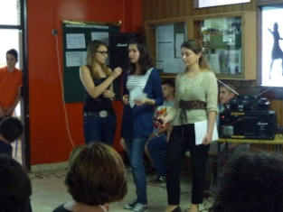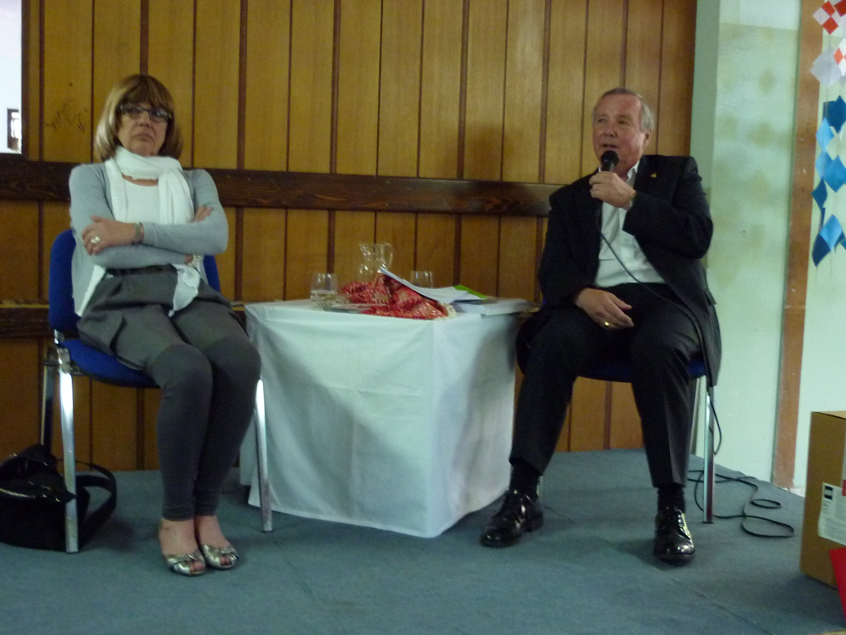
ECOLOGY
This topic was introduced with the famous quote from Shakespeare’s Hamlet. The crucial question ‘To be or not to be?’ and explaining the real meaning of these words - to know or not to know, to care or not to care, was presented by Fran Ćurković and Kaja Barić (grade 7), who connected it with the ecology in Denmark.
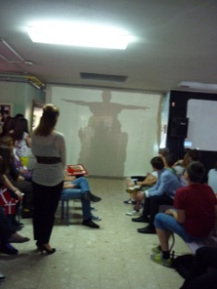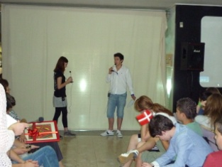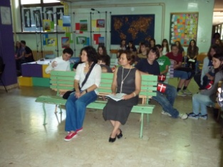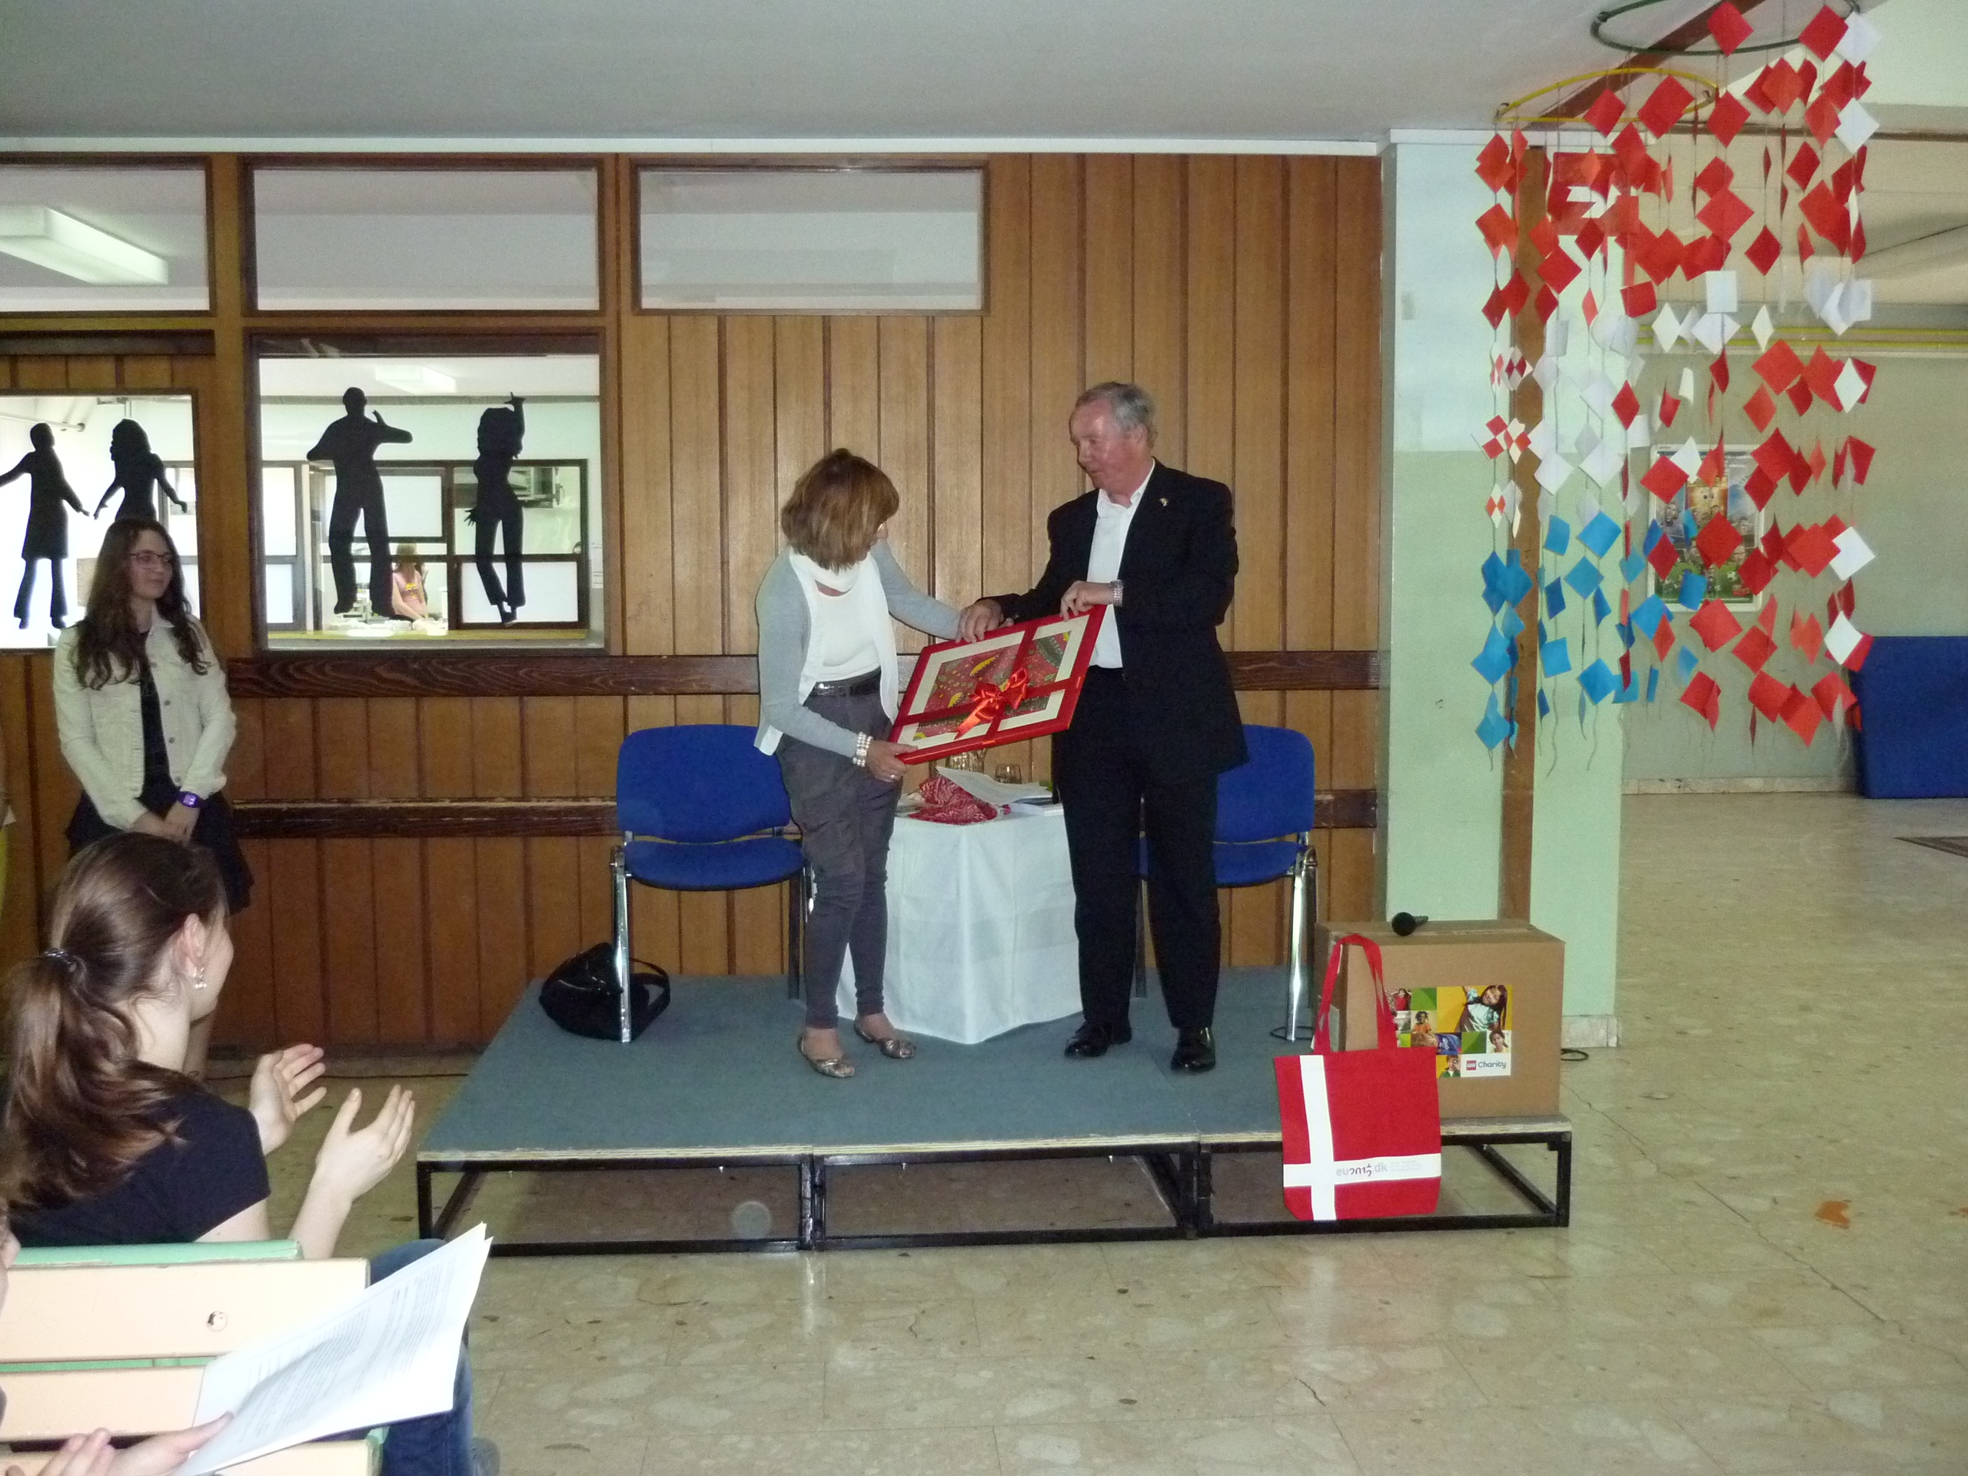

Final outcome and thanks
Everything started last year on Lake Bundek during the European Fair. Our school represented Denmark, so we got interested in this country and wanted to know more. We suggested the project to the Embassy and that is how everything started to develop. After months of hard work and planning, this project had recently been finished. We have really learnt a lot and everyone feels happy and proud of their work and achievements.
All the presenters are very thankful to our supervisor Mrs Marija Samardžija, who stood by us and made everything possible. We also thank our English teachers Mrs Dubravka Rojc and Mrs Marina Hadžiomerović, all the other teachers and staff members, as well as our host, the headmistress of Medvedgrad Primary School Mrs Blaženka Gašljević. Our special thanks are of course extended to our guests from the Danish Embassy who generously accepted our invitation and answered all our questions. This is the first time that a project like this was organized in Croatia. The main goal for us was bringing Europe closer and preparing young Croatians for the European Union. We chose Denmark as an example. This has undoubtedly been a great experience for all of us.

Ankica Pezo and Iva Balatinec, project organisers
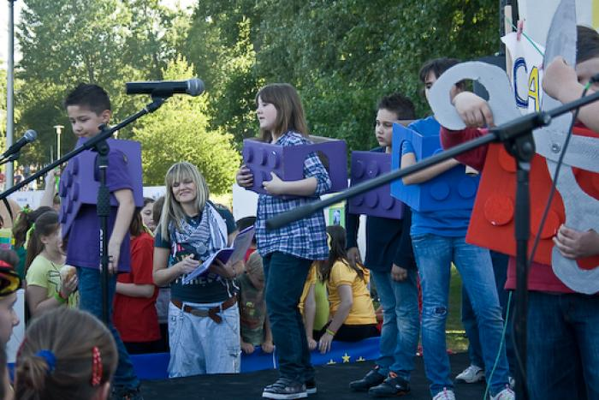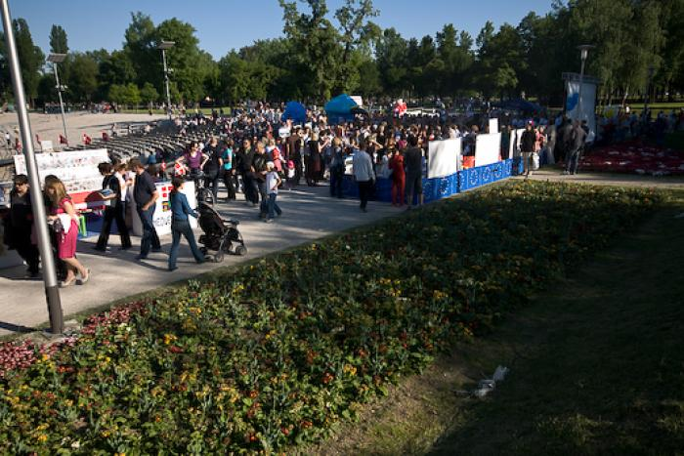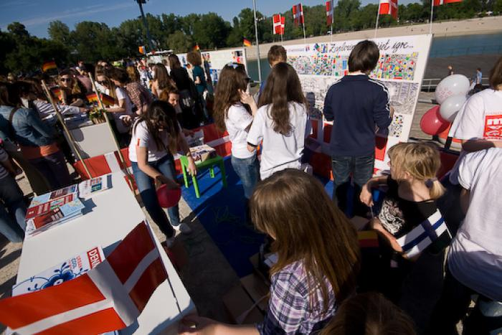 Zagreb, May 2012

Bundek Lake Fair “Rhythm of Europe”

